Chapter 16, Solution 32.

For the network in Fig. 16.55, solve for i(t) for t > 0.

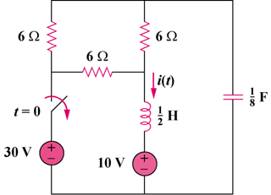

Figure 16.55
For Prob. 16.32.

Solution

Step 1. First, we need to find all the initial conditions. Then we need to transform the circuit into the s-domain and solve for I. We then perform a partial fraction expansion and convert the results into the time domain. The inductor becomes a short and the capacitor becomes an open circuit. Thus, i(0) = [20/6] + [20/12] = 5 amps and v_{C}(0) = 10 + 10 = 20 volts.

20/s

+
−

8/s

5/s

0.5s

10/s

+
−

4 Ω

I
+

Loop equation, –[10/s]–0.5s(I–5/s)–4I–[8/s]I+[20/s] = 0.

Step 2. [0.5s+4+8/s]I = [(s²+8s+16)/(2s)]I = –[10/s]+2.5+20/s = (s+4)/(0.4s) or

I = 5(s+4)/[(s+4)²] = [A/(s+4)]+[B/(s+4)²] where A(s+4)+B = 5(s+4) or A = 5 and B = 0. Therefore,
i(t) = [5e^{–4t}]u(t) amps.

